BASIC COMMANDS:
PWD :
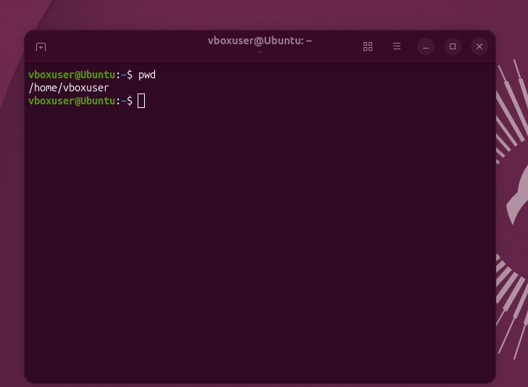

LS:
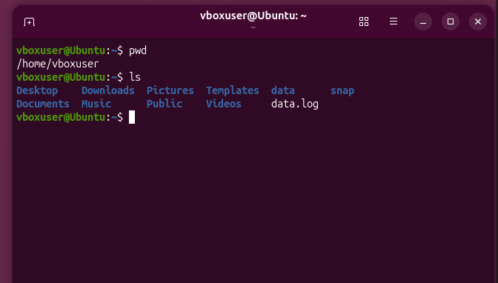
CD:
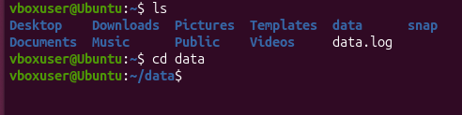
WILL HELP TO NAVVIGATE TO THE SPECIFIC DIRECTORY
MKDIR:
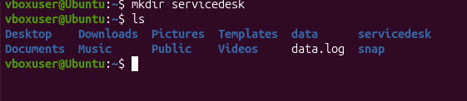
HISTORY:
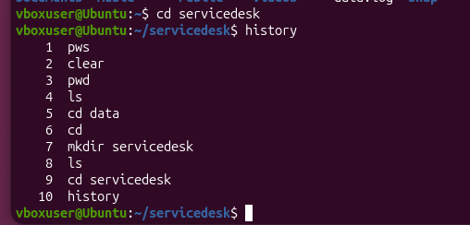
WHOAMI:
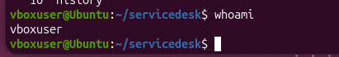

SUDO APT-GET INTSALL -VIM:
WILL HELP TO INSTALL ALL THE PACAKGES OF THE VI EDITOR

AFTER VI FILE NAME :
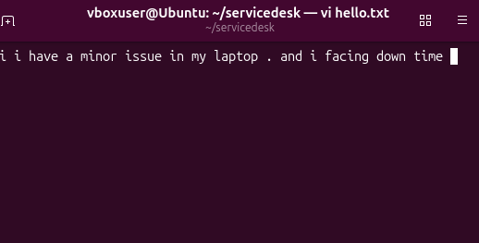
INSERT I AND AFTER INSTER ESCAPE +: + WQ WILL SAVE THE CONTENT OF THE FILE
AFTER INSERT + : + Q +! WILL EXIT WITHOUT SAVING THE CONTENT

TOUCH :
WILL CREATE THE EMPTY FILE
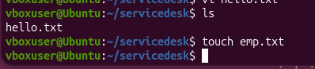

NANO TEXT:

BY USING THIS COMMAND WE CAN EDIT , COPY AND WRITE AND READ EEASILY THE CONTENT OF THE FILE WITHOUT COMPLICATION
RM :
WILL REMOVE THE MENTIONED FILE FROM HE FOLDER :
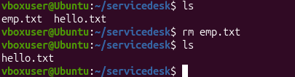
RM *.TXT:
WILL HELP TO REMOVE ALL THE TEXT FILES FROM THE DIRECTORY
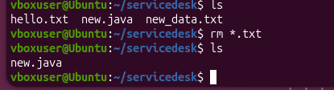
CAT WILL SHOW ALL THE CONTENT OF THE FILE WITHOUT OPENING THE FILE :
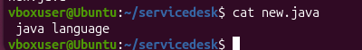
ECHO :
ECHO USED ADD CONTENT EXTRA TO THE EXSISTING FILE
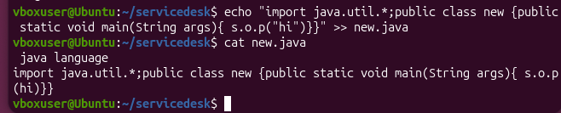
LS:
WILL SHOW ALL THE JAVA FILES IN THE DIRECTORY

CP :
WILL HELP TO COPY THE CONTENT OF THE FILE TO THE NEW FILE WITH EXSISTING FILE
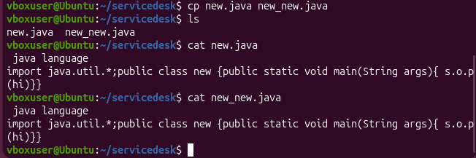
MV:
WILL MOVE THE FILE TO NEW FILE BY DELETING EXSISTING FILE
